# THE PRINCE’S TRUST BUSINESS PLAN PACK



#### THE GUIDE

WELCOME

### You’ve got a business idea. You’ve decided to start a business. You want to get going.

But there’s a lot more to a good business than a good idea. You need to think things through to maximise your chances of success. Are you the right person to run the business? Will customers like your product?

A business plan will help you turn an idea into a business. It needs you to think through all the parts of your business, to plan how everything will work. It will take a few weeks to write if you’re going to do it properly. Some parts will be easier to complete than others.

Stick at it because it’s not the final document that’s important, it’s the process. Although you want to have a good plan when you’re done, an OK plan is better than no plan.

###### The Prince’s Trust Enterprise programme

The Prince’s Trust has helped many young people to complete their business plans and start their own businesses. If you are aged 18–30 and unemployed or working fewer than 16 hours per week, then we might be able to help you. We have offices throughout the UK and in each there is a team of Enterprise programme staff.

To take part, you need to be interested in self employment and have a business idea that you would like help to test and

explore. The programme can then help you to see if your business idea will work and whether self employment is right for you.

If through this process you find out it is, the programme can offer mentoring support and, if you really need it, financial support to start your business. However, if self employment turns out not to be the right option, the programme can offer support

to secure other goals in employment, education, training or voluntary work.

We can’t guarantee that your business

will work or that we will be able to offer you money, but if you are up for a challenge and want our help to explore your business idea, get in touch and come and meet us.

## CONTENTS

#### SECTION ONE

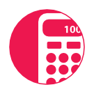

**04**

The quick pitch: executive summary and elevator pitch

#### SECTION TWO

**07**

All about you

#### SECTION THREE

**03**

What are you going to sell?

#### SECTION FOUR

**09**

Who are your customers?

#### SECTION FIVE

**10**

Do you know what it’s like out there?

#### SECTION SIX

**12**

How will you contact your customers?

#### SECTION SEVEN

**13**

Who are your competitors and how do you compare?

#### SECTION EIGHT

**14**

How will customers get the goods and you get paid?

#### SECTION NINE

**15**

How much will it cost?

#### SECTION TEN

**16**

How much money will you make? **£**

**20**

#### SECTION ELEVEN

What if it doesn’t work?

#### SECTION TWELVE

**21**

Business words explained

**02**

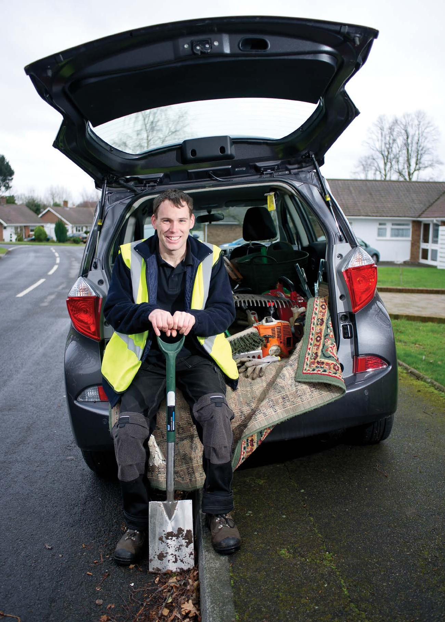

**03**

## THE QUICK PITCH

SECTION ONE

#### EXECUTIVE SUMMARY

###### Purpose of this section

This is the most important part of your business plan because if someone is busy, this might be the only section they read.

It should explain the basics of your business. After reading it, the reader should understand what the business is about and be keen to know more. It should include the key points of your business plan and should be short – no longer than two pages.

Because it is a summary of your business plan, you should write it last.

###### How to complete this section

Do not complete this section until you have finished the rest of your plan.

Please follow the steps outlined in the illustration below.

###### Business summary

Explain your business idea – what you are going to sell, where and to whom. Explain your business name and why you chose

it. Describe what type of business you have chosen to be – sole trader, limited company etc. Explain why you have chosen that structure.

###### Business aims

List three to five goals that you want to achieve through your business. For example, you might want to earn enough money to support your family or get your goods stocked in a particular store. You should divide your objectives into short- term (one year), mid-term (three years) and long- term (five+ years).

* 1. **Financial summary** Describe your financial goals for your first year – the turnover you hope to make and the amount of cash you hope to have left in the business at end of your first year of trading (these should be the amounts you worked out in your cashflow). State what money you need to start your business. Explain where you will get the money from (for example, the bank, The Prince’s Trust, family) and whether you are contributing any money yourself. If you

are not, explain why not.

**04**

#### ELEVATOR PITCH

###### Purpose of this section

This is the section where you plan how you are going to talk about your business. You should complete this section last when you have finished your business planning.

Planning your business is sometimes the easy bit – it’s more difficult to have the words ready to explain your business

to a potential customer on the street. You need to plan what you are going to say that makes it easy for people to

understand 1. What your business does,

2. Who it is for and 3. What makes it different to the competition?

###### How to complete this section

Do not complete this section until you have finished the rest of your plan.

Please follow the steps outlined in the illustration below.

###### Your business name



Your business name is important because it’s often the first thing people see on your marketing materials – for example, your website or later your

business premises. Your name helps customers to form an impression of what you do, what you stand for and to pick you out from the competition. You also have to live with it.

You need to think about 1. What your name says about you and your business, 2. How your name influences potential customers and 3. Whether the name you have in mind is already being used by another business.

###### Do you need a strapline?

This is a catchy phrase that goes with your business name and logo – for example, Cadbury’s Crème Egg – how do you eat yours?

Not all businesses need a catchy strapline. If you decide to have one it should emphasise the key selling point of your business, the bit that makes you stand out. It should be short, simple and catchy and strike a chord with your customers. Once you’ve decided on your strapline, you can include it in your marketing materials, website and in the bottom of your emails.

###### Your elevator pitch

This is a quick two minute summary of your business.

It’s the few sentences that you choose to tell potential customers when you have all but two minutes to leave an impression. Your elevator pitch should clearly state what your business does, who it’s for and why it’s different.

After a little practice, it will be second nature.

###### 05

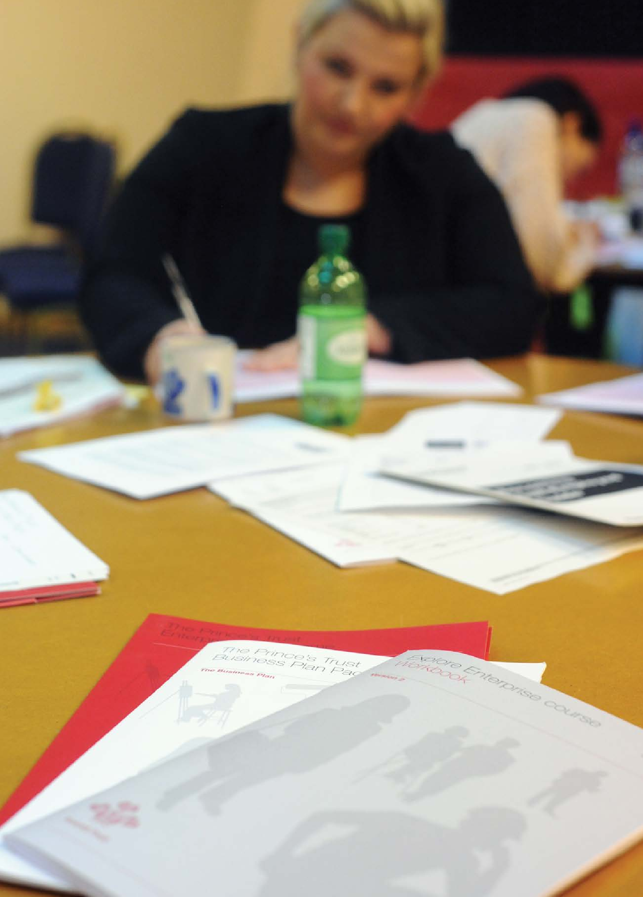

DESPITE EVERYTHING I’VE BEEN THROUGH I WAS THRILLED TO BE ABLE TO SET UP MY BUSINESS

– KELLY MCDERMOT

**06**

## ALL ABOUT YOU

SECTION TWO

#### OWNER’S BACKGROUND

###### Purpose of this section

This section is to explain why you want to start your own business and why you

think you (and, if applicable, your business partners) have the experience, ability

and commitment to make your idea a success. It should also give details of your education and qualifications, work

experience, training and hobbies. Practical experience is especially important.

###### How to complete this section

You should attach a CV for each person involved in the business and include copies of any certificates.

Please follow the steps outlined in the illustration below.

**2.1 Why you want to run your own business**

Why have you decided to start your own business? Why is it the right choice for you and why are you determined to make it a success? Why do you think you have the skills, knowledge and experience to make it work?

**2.2 Previous work experience**

Describe any experience you have in the activity of your business or in running another business. For example, if you have worked in the field or if you have helped your family to run a business.

**2.3 Qualifications and education**

Explain any qualifications you have which you think will help you to run your business.

**2.4 Training**

Describe any training courses you have been on which will help you to run your business. These might be business skills courses or courses to develop industry skills, for example, in carpentry or hairdressing. Give details of any training you plan to do in the future.

**2.5 Hobbies and interests**

Explain any activities you do in your spare time which will help you to make your business a success.

## WHAT ARE YOU GOING TO SELL?



SECTION THREE

#### PRODUCTS AND SERVICES

###### Purpose of this section How to complete this section

This section is to describe what your business is going to sell. Businesses

can sell two things – products or services. Products are objects, for example, clothes, jewellery, books, etc. Services involve selling time to do something for

a customer, for example, a plumber, car mechanic, etc.

Sometimes a business can do both, for example, a website designer who sells time to build a website (service) and the domain name and software to host the site (product).

People reading your business plan may not be familiar with your product/service so you need to explain everything, even things that seem obvious to you.

Get people who are not involved in the business to read your description to make sure they can understand.

Please follow the steps outlined in the illustration below.

###### 3.1. What are you going to sell?

Is your business going to sell a product, a service or both?

###### Describe the basic product/ service you are going to sell.

If your product is hard to explain it’s a good idea to include a picture.

###### Describe the different types of product/service you are going to be selling.

For example, if you were selling t-shirts, you might stock certain colours and sizes. If you were going to be a plumber you might have two services, one for commercial properties and one for domestic.

###### If you are not going to sell all your products/services at the start of your business, explain why not and when you will start selling them.

You may start your business after having done market research on a sample of products/services.

You may want to wait until you have a regular income before expanding the range of products/ services you offer.

## WHO ARE YOUR CUSTOMERS?

SECTION FOUR

#### THE MARKET

###### Purpose of this section How to complete this section

This section is to describe the customers that might buy your product/service.

You need to understand these customers so you can work out how to tell them about your business.

Be specific and find out detailed information about your target market - local customers who will be interested

in your business, not general information about all the customers in the world who are interested in businesses like yours.

The best proof that customers will

be interested in your business is if you have already sold some of your products/ services. The next best thing is to have customers waiting to buy from you.

Please follow the steps outlined in the illustration below.



**4.1 Explain whether your customers**

**are businesses or individuals**

Your customers might be both individuals and businesses.



**4.2 Describe your typical customer**

For example, if they are individuals,

broadly how old they are and how much they earn. If they are

businesses, what sector they are

in and what size of business they are.

**4.3 Describe where your typical customers are based**

For example, are they in the UK, in a particular region or worldwide.



**4.4 Explain what prompts your customers to buy your product/service**

For example, when they have a leaky tap or when they receive a big salary bonus.



**4.5 Describe factors that help your customers choose which business to**

**buy from**

For example, which business has the most experience, which business is nearest to them or which product they think is

in fashion.



**4.6 Explain whether you have sold any products/ services already**

Describe how many sales and how much money you

made. If you can, provide a

list of customer/ sales details.



**4.7 Explain how many customers you have waiting to buy from you**

Ask potential customers to write a ‘letter

of intent’, stating that they would like to buy your product/service and include copies in your business plan.

## DO YOU KNOW WHAT IT’S LIKE OUT THERE?



SECTION FIVE

#### MARKET RESEARCH

###### Purpose of this section How to complete this section

In section four, you described your potential customers. Most of these customers will already be using other businesses. This section is to research those businesses and customers.

Lots of businesses look good on paper but the only test that matters is whether the product/service sells. You can’t be sure that your assumptions about your business are right unless you do some proper research (i.e. don’t just ask your friends and family if they think it’s a good idea).

There is no right amount of research. It is better to research your local market, in the area you are going to run your business, than it is to research the entire global market. The right amount of research will tell you what your market looks like, how it behaves and what customers expect.

There are two types of market research outlined in the illustration below:

* Desk research
* Field research

Write up your findings including the most important information only.

###### Desk research uses information from the internet and books.

It involves learning what other people

say about your market and finding out basic facts. When writing a description

of your market, you should explain:

* how big the market is (for example, how many sales take place in a year?)
* trends in your market (for example, are

sales going up or down? Are people changing how they buy the product/ service?)

* any important facts, statistics or events
* whether the market is seasonal or dependent on other external factors (for example, the weather)

###### Good places to find information are:

* general area statistics:
  + upmystreet.com
  + businesslink.gov.uk
* government agencies:
  + statistics.gov.uk
* libraries: sector magazines and

directories, Yellow Pages, etc.

* your own knowledge from previous jobs or experience working in the field

###### Field research involves asking potential customers their opinion of your business.

It is the best way of working out if it will be successful. You should ask potential customers to complete questionnaires.

If you are selling a product, you should also carry out test trading to see whether people will buy your product.

###### Questionnaires

**When designing questionnaires:**

* keep it short – one page with about 10 questions
* ask questions answered “yes/no” or with

options, such as “very happy, happy, unhappy, very unhappy”

* ask specific questions – will people buy

from your business, at your prices, in your location

* ask if people buy from a similar business

already and if so, which? Would they change to buy from you and if so, why?

* ask if you can keep customers’ details

and contact them when you start trading

Include a copy of the questionnaire in your business plan.

###### In the main body of the business plan:

* explain how you chose the people who completed the questionnaire and how many people completed it
* describe the main results. For example

how many said they would buy your product/service? How many would be new customers? How many customers would you be taking off your competitors?

###### Test trading lets you practise running your business.

The aim is to see if customers will buy your product and at what price. It doesn’t have to cost lots to do. If you complete test trading, you should explain:

* where you did it and how much it cost
* how many products you tried to sell and at what price
* how many products you did sell and at

what price

* the key things you learnt
* the key things you will change
  + where you did it and how much it cost
  + how many products you tried to sell and at what price
  + how many products you did sell and at

what price

* + the key things you learnt
  + the key things you will change

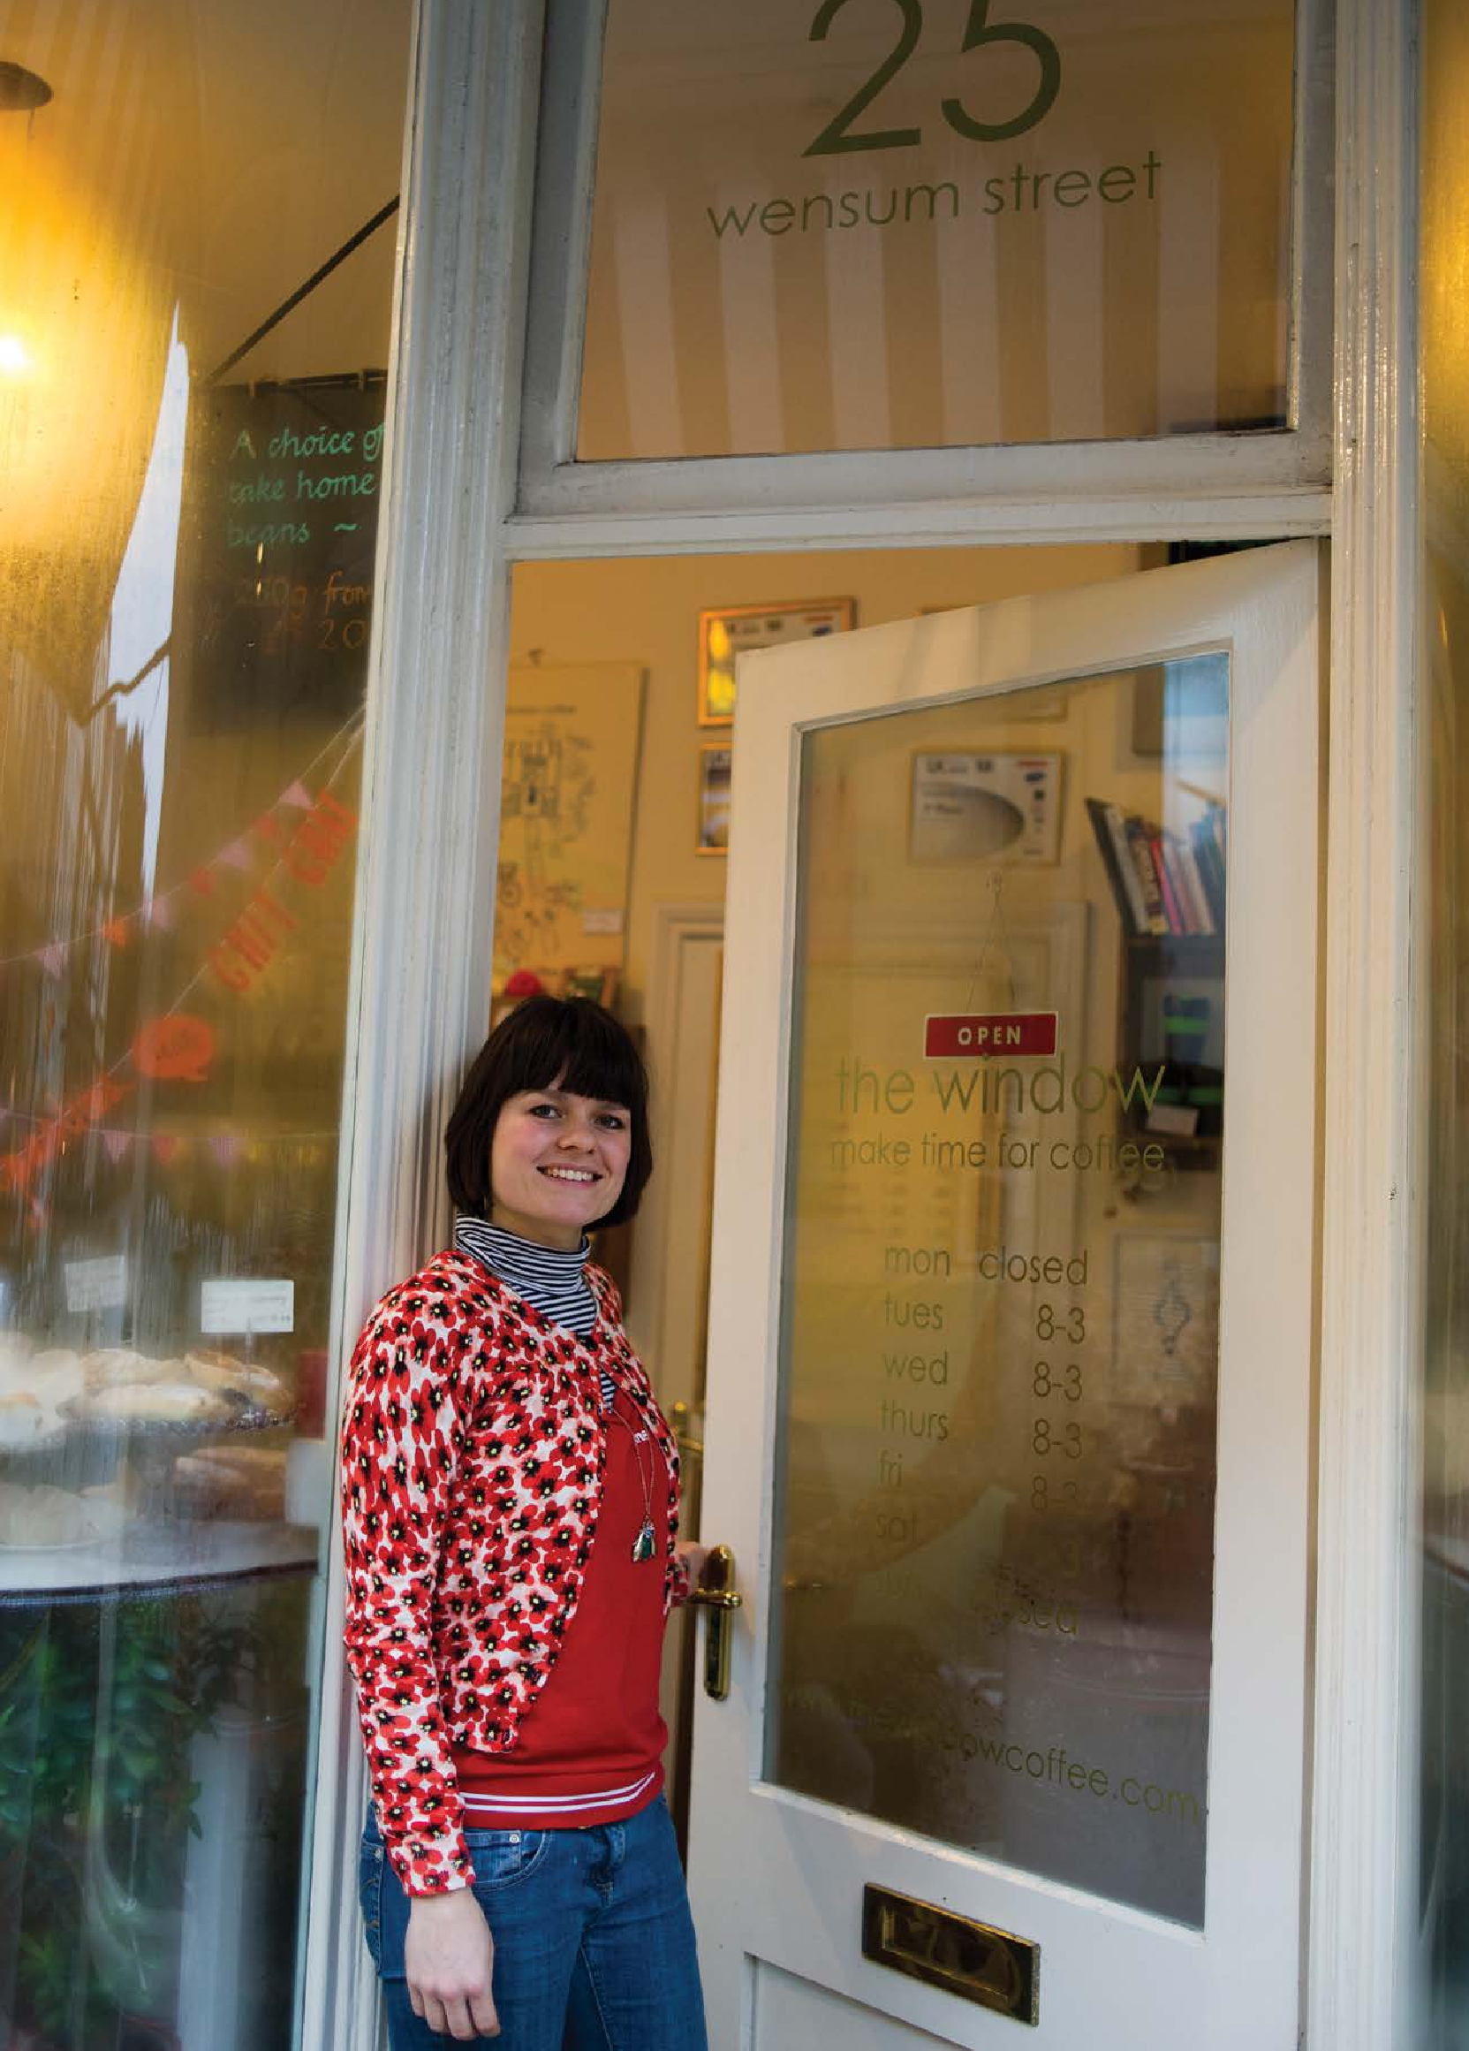

**11**

## HOW WILL YOU CONTACT YOUR CUSTOMERS?



SECTION SIX

#### MARKETING STRATEGY

###### Purpose of this section

You need to contact potential customers to tell them about your business.

Marketing describes any activity that attempts to make contact with potential customers.

Good marketing materials – in whatever form – will grab a customer’s attention, capture their interest, illicit their desire for your product/service and direct them to take action and find out more.

If your marketing is successful, your potential customers will learn what your business does and where to find you. Popular marketing methods are outlined below.

###### How to complete this section

Different marketing methods are outlined below. Decide which methods are best for your business; choose about three and list the required detail for each.

###### Important

You must include all costs in your cashflow forecast in section 10.3.

###### Word of mouth

When customers hear about your business through others, that’s word of mouth marketing. If customers like your business they will often recommend it all on their own. However, it is worth considering how you could encourage them to tell people, for example, by offering an incentive like a discount, or by giving exceptional customer service.

###### Advertising

There are many ways to advertise your business, for example, in a local paper, on the internet or in a directory like the Yellow Pages. You should explain:

* which methods you have chosen, why and how much it will cost
* the type of advert you will use, for

example, size or colours

* how many adverts you will use and how long each will run for

###### Business literature – leaflets and business cards

These should detail only the most important information about your business. You should keep the design and wording simple. If you have already produced some, you should attach them to your business plan; otherwise you should describe the design or include a sketch. You should also explain:

* what materials you will produce, what information will be on them and who will design them
* how many you will produce, who will print

them and how much it will cost

* if you are going to distribute materials to customers, explain how and where

###### Direct marketing

Direct marketing involves contacting potential customers to directly sell your product/service to them. It can be done on the phone, in a letter, email or face-to- face. You should explain:

* which method of contact you will use, why and how much it will cost
* how you will find names and contact

details of potential customers

###### Social media

Different social media can be a very effective way of marketing your business. It’s free, allows you to put a face on your business and invites a vast network to interact with your activities. As well as the widely used Facebook and Twitter, there are now social networking sites for small businesses which can help you

to focus your efforts. If you’re planning on using social media to market your business, you should consider:

* what you want to achieve from social networking and how you will engage with your customers, for example, will you create a blog to give customers the inside view on your business or get customers to offer feedback on product design?
* which networking sites are preferred by your target market and for what purpose
* how your business activity on social

networking sites is kept separate from your personal activity

* how your social networking ties in with your website or other promotional materials and events

###### Tradeshows and exhibitions

Some businesses can access large audiences at a tradeshow or exhibition. However, exhibiting is expensive and time consuming, so you need to be sure it will be worth the effort. If you plan to attend events, you should explain:

* which events you are planning to attend, when and how much it will cost
* why it is important to attend these events

at this stage in your business

###### Website

Websites don’t have to be complicated - just three or four pages to show what you do and how to contact you. If you already have a website you should give the address. If you don’t have one but plan to, you should explain:

* the design and any special functionality you want to include, for example, an online shop
* who is going to design it for you and how

much it will cost to build and maintain

**You can refer to The Prince’s Trust in your marketing materials using the words ‘Initially supported by The**

**Prince’s Trust Enterprise programme. You cannot use The Prince’s Trust logo.**

## WHO ARE YOUR COMPETITORS AND HOW DO YOU COMPARE?



SECTION SEVEN

#### COMPETITOR ANALYSIS

###### Purpose of this section How to complete this section

A competitor is any business that offers a product/service that is similar to yours.

Businesses often have many competitors. It’s best to focus on those which customers are most likely to buy from instead of you; probably those nearest to you, with the most similar prices or the most similar products/services.

You need to think hard about your business and how you compare to your competitors. You should put your thoughts in a SWOT analysis. SWOT stands for Strengths, Weaknesses, Opportunities and Threats.

A SWOT analysis will help you to understand all the things, good and bad, that could affect your business. If you know what these are, you can work out how to resolve them or use

them to your advantage. Thinking about your weaknesses and what could go wrong is important because it will allow you to correct your mistakes before they happen.

Please follow the steps outlined in the illustration below.

**7.1 Table of competitors**

Find out information about your competitors. Try to do this for at least five competitiors.

**7.2 SWOT analysis**

Each part of a SWOT analysis is explained below. Try to think of three points for each category. Make sure each point is specific to your business.

**You need to work out:**

* who they are **Strengths**
* where they are > Positive things about your business that
* what they sell will make it stand out against competitors.
* how much it costs These might be specific to your product/
* how big the company is service or more general, such as your
* what their main strengths location and weaknesses are

**7.3 Unique Selling Point (USP)**

Your USP is the thing that makes your business different from your competitors. It might be specific to your product/ service or it might relate to the way you run your business. It would be the reason that customers stopped using a different business and became your customer. Be specific and avoid clichés, such as, better quality products, better customer service or cheaper products. Consider *how* you will show your customers that you are the better choice.

**Weaknesses**

* All the things that could mean you **If you can’t think of a USP you need** struggle to make your business work. **to review and improve your business** For example, areas that might be affected **idea so that there is something that** by your lack of experience or by lack of **makes you different or better than** money **your competitors.**
* For each weakness, explain what you are

going to do to address it, for example, more training

**Opportunities**

* External factors that you and your competitors can take advantage of, for example, changes in the law or market trends

**Threats**

* External factors that could affect how well your business and your competitors do. For example, a large shopping mall opening up that might take away your customers
* Explain how you will prepare for these

and how you will reduce their effect on your business

## HOW WILL CUSTOMERS GET THE GOODS AND YOU GET PAID?

SECTION EIGHT

#### OPERATIONS AND LOGISTICS

###### Purpose of this section How to complete this section

It’s important to work out how your business will work on a day-to-day basis. It’s easy to forget little things and it’s surprising how many people forget big things, like working out when and how to get paid. Imagine you are preparing for your first sale; work through the different stages, from making or buying your



Different stages to think about are outlined in the illustration below.

###### Important

You must include all costs in your cashflow forecast in section 10.3.

###### 8.3 Payment

product through to delivering it and taking the money.

###### 8.1

**Production**

If you are making your product, how long will it take? If you are buying it, how long will delivery take? Is there a minimum order? Do you have

###### 8.2 Delivery to customers

How long will it take to

When will you get paid and how – for example, with credit

cards, cheques or cash? The payment methods you choose can have an impact on the cost of running the business. For example, a merchant service provider often

charges a monthly rental fee as well as a fee on debit and credit card transactions which affect what you charge for your product

or service. Will your customers pay you

to pay upfront? How much stock do you really need

to order?

deliver your product to your customers and how will it be delivered? Is the cost of

upfront or pay a deposit and the rest when you finish? Who will do your

books and how often?

###### Suppliers

Explain who you have

delivery included in the cost of the product or will you

charge customers extra?

###### Premises

chosen, what they will supply and when you will pay them, for example, upfront or within 30 days. Consider how your costs and prices will differ if you are buying or selling your products wholesale. Include

at least two quotes and a back- up option in case they let

you down.

###### Transport

How will you get about – for example, to pick up stock or to meet

customers? How much will it cost? Do you need a driving licence? If you do and you

don’t have one, what will you do?

###### Legal requirements

What laws apply to your business, for example,

registering with the Council if you

###### Equipment

What equipment do

you need – for example, a computer, a mobile phone, a sewing machine? What will you use each item for, how much will it cost and where will you

buy it from or do you own it already?

###### Insurance

Insurance protects your business against risks. There

Where will you run your business from? Describe the

space and explain why it is suitable.

Working from home may be easiest and cheapest but will it work and do you have permission from the owner or the

local authority? If you plan to rent premises, think about the cost, the type of contract, the facilities (for example, telephone and

internet) and whether it is convenient for your customers. If you are selling on a market, when will you trade? How

do you rent a stall? Is there a waiting list?

deal with food or with HMRC for VAT if your turnover is over the limit? Do you need a trading

licence? Where would you go to get legal advice?

are many types, for example, public liability (in case someone sues because they suffer a loss they think is your fault), contents (to protect stock and equipment), and goods in transit (to protect goods being moved in vehicles). Make sure you research which types of insurance you need and

include at least two quotes for each.

Try looking on simplybusiness.co.uk or moneysupermarket.com/

business-insurance.

###### Management and staff

Will you run the business on your own? If people will be helping you, what will they do?

## HOW MUCH WILL IT COST?

SECTION NINE

#### COSTS AND PRICING STRATEGY

###### Purpose of this section

Before you decide how much to sell your products/services for, you need to work out how much each one costs you to make and deliver. This will stop you selling things for less than they cost.

The price you charge customers for

a product/service must be higher than its cost and include enough money to cover the extra costs of running your business (for example, petrol, bills, rent etc.) and your essential personal costs

taken from your personal survival budget. The difference between an item’s cost and its price is its profit margin.

###### How to complete this section

To work out your costs, use the table provided. Each of the rows are explained below.

* If you are completing this form in MS Excel, these sections will calculate automatically.

**A.**

If you can’t work out the price of a single product/service, you can work out the price of a batch. For example, for food

this might be on portions of four or for T-shirts, a batch of 10.

**B.**

Break down your product/ service into parts (for example, different materials, packaging, labels, etc.) and put each one in a separate box. Work out the cost of each and write it down in the relevant box.

**C.**

Work out the total cost of the different parts of your product/ service (add up all costs in B).*

**D.**

If you worked out the cost of

a batch, i.e. for more than one product/service, to work out the cost of an individual unit, divide the total cost (cost C) by the number of products/ services in your batch

(cost A).*

**E.**

Work out a price that will cover the business overhead costs and give reasonable profit.

Compare this price with your competitors to see where you stand. This (cost E) is the price you will charge your customers.

**F.**

Work out the difference between your unit cost (cost D) and your price per unit (cost

E). This difference is your profit margin (£).

**G.**

Work out the profit margin as a percentage (%) by dividing your profit margin (cost F) by your unit price (cost E) and multiplying by 100.

**H.**

Work out the mark up by dividing your profit margin (cost F) by your unit cost (cost D) and multiplying by 100.

**Once you have worked out the price for each of your products/services, compare it to your competitors. If your price is more expensive, you need to think whether customers will pay extra to buy from you.**

## HOW MUCH MONEY WILL YOU MAKE?

SECTION TEN

**£**

#### FINANCIAL FORECASTS: 10.1 SALES AND COSTS FORECAST

A sales forecast shows how many sales you are aiming to achieve in your first year and how much money that would mean you receive. It’s hard to know what a realistic number of sales might be so it’s better to plan for the worst case.

For lots of businesses, the number of sales made is affected by external factors such as, holidays, seasons, weather, etc. Think whether you expect your sales to be different in some months and show this in your sales predictions.

A cost forecast shows how much money you will spend on products/services if you achieve the number of sales in your sales forecast.

Complete the sales/costs forecast

table provided, following the instructions shown below.

* If you are completing this form in MS Excel, these sections will calculate automatically.

**Sales calculations**

1. Write in the names of the months. Month one should be the month in which you plan to start trading.
2. Write down how many sales you plan

to make in each month. To do this, work out how many products/services you think you can sell in a day. Multiply that number by the number of days in a week you

plan to trade. Lastly, multiply that number by 4.3 (average number of weeks in a month) to give you the number of sales you plan to make in a month.

**Costs calculations**

D.Work out how much money you will spend each month if you make your predicted sales. To do this, take the number of sales (B) and multiply it by its cost (cost D in the cost/price table in section nine).*

**Assumptions**

E.Describe any assumptions you made, for example, external factors affecting number of sales. For example, if you were selling umbrellas you would expect higher sales in winter because it rains more.

C.Work out how much money you will make each month. To do this, take the number of sales (B) and multiply it by its price (cost F in the cost/price table in section nine). The total income you receive from sales in a year is called your turnover.*

SECTION TEN

**£**

#### PERSONAL SURVIVAL BUDGET

###### Purpose of this section

A survival budget shows the amount of money you need each month to live on. To work it out add up all the money

you spend and take away any money you get as income from sources other than your business.

###### How to complete this section

Complete the personal survival budget table provided, following the instructions shown below.

* If you are completing this form in MS Excel, these sections will calculate automatically.

A.List all the different things you spend money on each month. Some of these will have predictable costs, for example, rent, and others will vary, for example, entertainment costs. For the items that vary, you should work out how much

on average you spend a month. Do not include your business costs.

B.Add up all the different costs in part

A to work out your total monthly costs.*

C.List income you receive every month; including income from a part-time job or from benefits such as Child Benefit, New Deal or Working Tax Credits.

Things you might want to include are:

* mortgage
* rent
* council tax
* gas and electricity
* water rates
* personal and property insurances
* food
* clothing
* telephone
* hire charges (TV, video, etc.)
* entertainment (meals, drinks, cinema etc.)
* subscriptions (gym, magazines, etc.)
* car tax and insurance
* car service and maintenance
* children’s expenditure and presents
* savings plan
* credit card and personal loan repayments

D.Add up all the different amounts in part

C to work out your total monthly income.*

E.To work out the income you require from your business, take away your total income (D) from your total costs (B).*

SECTION TEN

**£**

#### CASHFLOW FORECAST

###### Purpose of this section How to complete this section

A cashflow shows how much money is expected to come in and out of your

business. It brings together all the work you have done in your plan. You must complete the forecast realistically. Make sure you:

* include seasonal changes in overhead costs such as increased heating and lighting bills in winter
* allow for delays between when you make

a sale and when you receive payment

* do not over estimate how much stock you will need
* split costs that can be paid on a monthly

or quarterly basis

Once you start your business you will have to keep a record of your actual income and expenditure and you should compare this to your plan to give you an idea of how well your business is doing.

Complete the cashflow forecast table provided, following the instructions below.

* If you are completing this form in MS Excel, these sections will calculate automatically.

1. The columns show the months in your first year of trading. Write in the names of the months. They should be the same as in your sales/costs forecast in section 10.1.*
2. The top rows show money coming into your business and when. You should list each type of income on a different line. Typical types of income you should include are:

* income from sales (should be the same

as in your sales/costs forecast in section 10.1)*

* loan funding
* any of your own money that you are putting into the business

1. For each month add up the total amount of money you have coming into your business.*
2. The middle rows show money going out of your business. List each cost on a different line. Include all the costs

you have worked out in earlier sections of your business plan, for example, marketing costs, equipment costs, personal survival budget. Other costs to include are:

* tools
* materials/stock
* rent/rates
* heat/light/water
* phone
* postage
* printing and stationery
* insurance and tax
* motor repairs/maintenance
* petrol/diesel/other travel costs
* IT costs
* loan repayments

You should explain what each cost relates to in your costs table in section 10.4 of your business plan.

1. For each month add up the total amount of money you have going out of your business.*
2. The bottom rows show how much money is in your business at the beginning and end of each month.
   1. Balance – take the money earned in that month (C) and subtract the money spent (E).*
   2. Opening balance – should be the same as the closing balance of the previous month.*
   3. Closing balance – the month’s opening balance (b) plus the current month’s balance (a).*

###### Breakeven

Your breakeven point is the number of sales you need to make to cover the costs of running your business. To calculate your breakeven:

1. Work out the annual cost of running your business (The total column in row E of your cashflow).
2. Divide cost G by your gross profit margin percentage (row G in the cost/price table in section nine).
3. To work out how many sales you need to make in a week, divide H by the number of weeks in a year you expect to work.
4. To work out how many sales you need to make in a day, divide J by the number of days in a week you expect to work.

SECTION TEN

**£**

#### COSTS TABLE

###### Purpose of this section

The costs table explains what is included in each cost in your cashflow. It also explains what assumptions you have used to work the cost out.

For example, you might have a cost line for travel to pay for the petrol you need. In the costs table you would explain how much petrol you have assumed you will use (for example, how many tanks) and

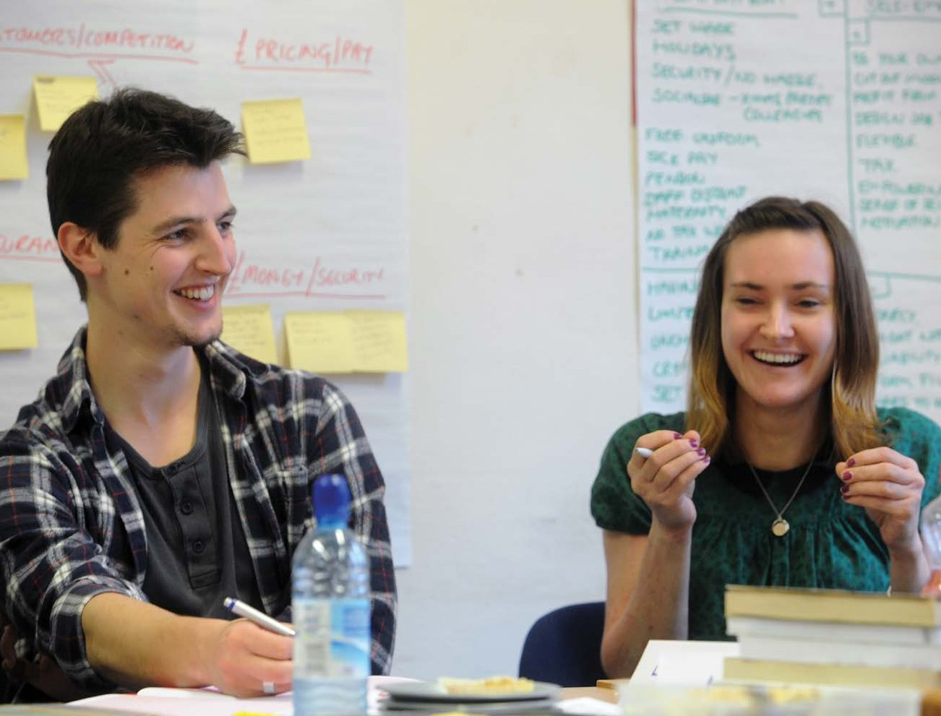how much you have assumed that will cost (for example, how much one tank costs).

###### How to complete this section

If you have explained your costs in your cashflow in a different section

of your business plan, you should write in the costs table where the detailed breakdown of the costs can be found. For example, your marketing costs will be explained in section five.

For all other costs in your cashflow you should explain what they include and how you have worked them out.

## WHAT IF IT DOESN’T WORK?



SECTION ELEVEN

#### BACK-UP PLAN

###### Purpose of this section How to complete this section

Sometimes, despite careful planning, the unexpected will happen and a business will fail. There are many reasons why a business might fail; a lack of cash, a new competitor or changes in your personal life.

Nobody plans to fail but it is important to plan for the ‘what if’ scenario. What if doesn’t work out as you imagined?

Sometimes all that could be required is changes to your existing business that reduce your costs or boost your income. Other times, it may be that, despite your best efforts, you have to close the

business and tackle Plan B. And it’s far better to have a Plan B in your back

pocket ready, if and when the unexpected happens.

Please follow the steps outlined in the illustration below.

##### 11.1

###### Think about what changes you may be able to make to your business in the short- term that would help you to make cost savings or earn more money.

For example, can you work with a cheaper supplier, negotiate shorter payment terms with your customers or boost sales with effective networking?

##### 11.2

###### Consider what changes you may be able to make longer- term.

For example, can you do more of your business online or take a part-time job or training course - helping you to meet new people and learn new skills that might benefit your business?

##### 11.3

###### If you do decide to close your business, consider what skills and experience you have now – and as a result of doing the Enterprise programme – that would help you to take your next step.

For example, what contacts do you have who would be willing to help you; what support might be available from The Prince’s Trust?

##### 11.4

###### Think about what you have learned as a result of running your own busines.

For example, what positives can you take from running your business; what lessons have you learned; what contacts have you made; what skills and experience do you have now that you didn’t have before; how would these be interesting to an employer?

## BUSINESS WORDS EXPLAINED

SECTION TWELVE

### This table explains the meaning of some of the words that people often use when they talk about business.

ASSETS

Things a business owns, e.g. buildings, vehicles, stock and money in the bank.

BRAND

Refers to the words and symbols such as a name, logo and slogan that represent a business’s identity.

BREAKEVEN

The amount of sales a business needs to make to cover all

its costs.

BUSINESS PLAN

A document that describes a business’s aims and objectives and a plan for how they can

be achieved.

CAPITAL EXPENDITURE

Money spent on buying

or improving items that will be owned by a business for a long time, e.g. buildings or equipment.

CARBON FOOTPRINT

A measure of the impact that human activities have on the climate in terms of the total amount of greenhouse gases produced.

CASHFLOW FORECAST

An estimate of the amount of money a business will spend and receive within a certain time period (usually a year).

CREDITOR

Somebody to whom a business or individual owes money.

ELEVATOR PITCH

A two minute summary that explains (i) what your business does (ii) who your customers are and (iii) what makes your business different from the competition. A customer should have a clear understanding of your business and its Unique Selling Point after hearing your elevator pitch.

EXPENDITURE

Money paid; cost.

FIXED ASSETS

Things a business owns or controls for a long time, such as premises or equipment.

FIXED COSTS

Costs that stay the same, regardless of how many sales a business makes, e.g. rent.

GROSS PROFIT

Total income from a business’s sales minus the direct costs of making the sales (this does not include a business’s overhead or running costs).

KEY MESSAGES

The things you most want customers to remember about your business.

LETTER OF INTENT

A signed statement from a potential customer outlining what product/service they are interested in buying from you and how many.

MARGIN

The difference between

the selling price of a product/ service and its costs. The higher the margin, the more profit that is made.

MARKETING

Any activity a business does to try and contact potential customers.

MARKET POSITIONING

How a business presents

its products/services in relation to its competitors; higher quality, cheaper, etc.

MISSION STATEMENT

A sentence to describe where your business is going or what you want to achieve in the long- term.

NET PROFIT

A business’s total income minus its total costs.

OBJECTIVES

Things a business wants or sets out to achieve.

OPERATIONS

The day-to-day activities that take place within a business.

PROFIT AND LOSS ACCOUNT

Shows a business’s total income and expenditure for a given period of time.

PROSPECT

Someone who could become a customer.

PUBLIC RELATIONS (PR)

Two-way communication between a business and anyone who is interested in it.

REFERRAL

A customer gained through a recommendation from someone else.

RESOURCES

The money, people, time and equipment needed to run a business.

STOCK

All the raw materials and finished goods owned by a business.

STRAPLINE

A catchy phrase that sums up a business’s message, for

example: ‘Cadbury’s Crème Egg – how do you eat yours?’.

TARGET MARKET

The group of customers a business chooses to focus its marketing efforts on.

TURNOVER

A business’s total sales income for a year.

USP (UNIQUE SELLING POINT)

A benefit that a business offers to its customers that its competitors do not.

VALUES

The principles and beliefs that guide what a business does and how it does it.

VARIABLE COSTS

Costs that vary in line with a business’s level of sales.

VIABLE

If a business idea is viable, it means that it should work and the business should be a success.

VISION

A business’s long-term goal.

**21**



**For more information on The Prince’s Trust, go to:**

# princes-trust.org.uk

### Or call 0800 842 842

DSN2669/2 © The Prince’s Trust 2015 – all rights reserved. The Prince’s Trust is a registered charity, incorporated by Royal Charter (RC000772).

Principal office: Prince’s Trust House, 9 Eldon Street, London, England EC2M 7LS. Registered charity number in England and Wales (1079675) and Scotland (SC041198).